Bull. Fac. Agric., Univ. Cairo 48
(1997): 329-350

EFFICIENCY OF BIOCONVERSION OF CHICKEN
FEATHER BY TRANSCONJIJGATED BACTERIAL
STRAINS

(Received 28/10/1 996)

By

H. EI-Fada1y and K.A. Zaied**
* Dept. of Agricultural Microbiology and

** Dept. of Genetics, Faculty of Agriculture,
Mansoura University, Mansoura, Egypt.

ABSTRACT

Four bacterial isolates of the genus IVlicrococcus and three related to the genus Bacillus showing high potency in feather-degradation were isolated from different environmental pollutants and identified. Feather-biodegradation was monitored by measuring free amino acids content, total soluble peptides, keratinase and proteinase activities during the course of fermentation process. Bacterial transconjugation was also conducted between bacterial strains that carrying different plasmid marker genes. The data obtained demonstrated higher potency of the transconjugants in feather hydrolysis than parental strains, The analysis of variance showed significant differences among the variables affecting feather-biohydrolysis.

Key words: Bacillus sp, Biodegradation - Feather - Micrococcus sp. Plasmid markers.

INTRODUCTION
Feathers is considered to be one of the commercial poultry processing by-products which, if neglected, causes an environmental

- 329 -

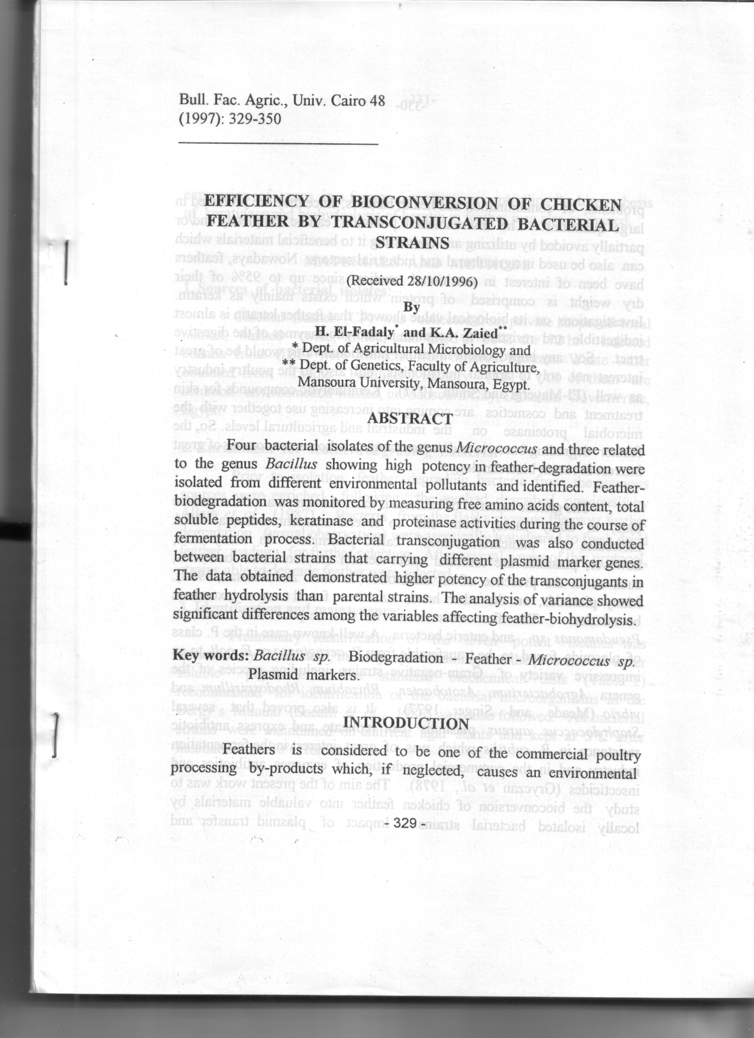

- Efficiency of bioconversion of chicken feather by transconjugated bacterial strains
المجلة العلمية زراعة القاهرة, الصفحات 329-350, 1/4/1997
أ.د. حسين عبدالله محمد الفضالى
K. A. Zaied

