FACILE AIR PLASMA-INDUCED GRAFT POLYMERIZATION PROCESS TO CONCLUDE
ACTIVE GROUPS ON POLYSULFONE FILM SURFACE WITH PERMANENT HYDROPHILICITY

Shereen A. Abdeldayem *^{1,2,3}, Tarek M. Abou Elmaaty¹, Stephen J. Russell², Parikshit Goswami³

¹ Faculty of Applied Arts, Textile Printing, Dyeing and Finishing Department, Damietta University, Damietta, 34512, Egypt.
² Nonwovens Research Group, School of Design, University of Leeds, Leeds, LS2 9JT, UK
³ Fiber and Fabric Functionalization Research Group, School of Design, University of Leeds, Leeds, LS2 9JT, UK
*Corresponding author. PhD student

Abstract
Active groups were induced to the surface of polysulfone (PSU) films by using air plasma and then post-grafted with methacrylic acid (MAA) followed by reaction with amine groups to enhance the hydrophilicity of the film and its stability. The modified films were characterized by surface tension and contact angle to evaluate the hydrophilic properties and atomic force microscopy (AFM) to analyse morphological structures. Creation of functional groups was determined by ATR-FTIR while grafting yield was estimated by weighing of films both before and after grafting. Results showed that the hydrophilic properties of PSU film greatly enhanced. This enhancement was obtained after plasma treatment but it was not stable over time, however after amination, it has been improved and remained stable over 40 days. The results of creating active groups such as amide group led to the availability of covalently attached with cyclodextrins (CDs) as potential candidates to capture drug molecules such as Ketoprofen, Meloxicam and Ibuprofen.

Keywords: PSU film, air plasma, post-grafting, hydrophilic properties, cyclodextrins, drug delivery system

- Introduction
Polysulfone (PSU) is a kind of aromatic thermoplastic polymer[1] and it is a popular membrane material because it possesses excellent mechanical property, thermostability, chemical inertness[2], process ability[1] and also excellent film-forming properties[3].These characteristics have led to use it widely in biomedical ﬁelds, such as blood puriﬁcation[4]. However, it is found that it might be a limit in use due to the hydrophobicity of the surface[5] and insufficient blood compatibility[4]. Various research groups endeavoured to overcome the problem of this limitation by using several physicochemical techniques, like UV radiations, electron beams, gamma rays and plasmas. Plasma is one of the mostly high potential techniques for modification of material surfaces [6]. Plasma-surface modification supplied most of polymer substrates with specific functional groups regardless their structure and chemical reactivity[5]. Low-pressure plasmas are a highly mature technology developed to achieve an effective and economically viable batch functionalization of fibrous product. An important advantage of this technology is that it is a well-controlled and reproducible technique [7]. In addition, it consumes far less gas, a factor that is particularly important for expensive gases [8]. However, the hydrophilic properties of polymeric materials which improved by the plasma treatment, is not permanently sustain [9-11].Thus, reactive groups attached by plasma treatments may in time become partially or wholly unavailable for interfacial bonding[10]. In order to solve this problem, plasma induced graft polymerization (PIGP) is used by grafting hydrophilic monomers, such as acrylic acid (AA)[6, 12, 13] because it is very convenient monomer for plasma processes. It is volatile, soluble in water and polymerizes easily. Additionally, the molar ratio of carboxyl group in the whole molecule is high, which should enlarge wettability of a substrate[13].The results of previous works with PIGP on PSU by AA in solution phase[6, 12, 13]showed that there is a layer of material with pure poly (acrylic acid) with high proportion but it can be removed easily from the surface of material leaving small amount of AA grafted on the surface which makes the surface of material is still hydrophobic. In these cases, it is necessary to find method to reduce removing of poly acrylic acid from the surface which improves its hydrophilic properties and its permanence. Furthermore, the created reactive groups allow sequent attachment with functionalised molecules such as CDs. CDs are a family of cyclic oligosaccharides and they used widely in wide range of applications regarding their structures, that have the ability to form inclusion complex with variety of long chain aliphatic or aromatic molecules such as drugs, pesticides, hormones, detergents, fragrances and vitamins [14-16]. Pharmaceutical applications are the most remarkable applications of CDs [14] due to various purposes, including improving the bioavailability of drugs [17]. So, the goal of our research is to enhance the hydrophilicity of PSU film and its stability by PIGP with (MAA) followed by amination with diamino-dipropylamine (DADPA). Consequently, it can benefit from creation of active groups on the surface of resulted material to potentially applied in drug delivery system such as analgesic drugs e.g. Ketoprofen, Meloxicam and Ibuprofen. Modified films were characterized by surface tension and contact angle, atomic force microscopy (AFM) and the creation of functional groups was determined by (ATR-FTIR).

- Materials and Methods
  - Materials
Polysulphone PSU (Mn ̴16,000), Dimethylformamide (DMF), 1-ethyl-3-(3-dimethylaminopropyl) carbodiimide hydrochloride (EDAC), N-hydroxysuccinimide (NHS), 2-(N-morpholino) ethanesulphonic acid (MES), Methacrylic acid (MAA), sulphuric acid (H₂SO₄), sodium hydroxide (NaOH), diamino-dipropylamine (DADPA) and ammonium cerium(IV) nitrate were all purchased from Sigma–Aldrich company and used as received.

  - Preparation of PSU film
Flat sheet of PSU film was prepared by the dissolution of PSU (25 wt. %) in DMF (50 ml) at room temperature to give a final concentration of 0.25 g.ml⁻¹. The reaction mixture was stirred for 24h. to obtain a homogeneous solution. Free standing film was obtained by the evaporation of DMF from the cast solution by slow drying in atmosphere through overnight.

  - Plasma induced graft polymerization
PSU films were treated with modified previously reported method [18] by low pressure plasma using air for different durations (15, 30 and 45 min) to study the effect of plasma treatment time on the graft yield of MAA. In brief, the plasma treatment system (low pressure plasma) was provided by Diener electronic (Model: PICO) Co., (Ebhausen) with the following experimental conditions: a plasma power of 60W and flow rate of 15 sccm. The PSU films were treated by air plasma subsequently; the films were placed in a clean plastic bag to minimize potential contamination. After plasma treatment, the film immersed into 20 vol. % MAA aqueous solution with 0.4M H₂SO₄ and 0.073M ammonium cerium(IV) nitrate. After purging with nitrogen, the solution was heated under 80◦C for 40 min.
The PMAA grafted PSU films were thoroughly rinsed in 10mM NaOH solution for 6h and finally rinsed in DI water for 24h.The PSU-PMAA films were immersed into MES buffer solution (0.1M, pH 5.0) containing 10mg/ml EDAC and 10mg/ml NHS at room temperature for 1h. This reaction activated the carboxyl groups on the PMAA grafted PSU films surface. After the activation, the films were immersed in 30 vol.% DADPA solution and reacted under 4◦C for 2h. The PSU–PMAA–DADPA films were rinsed with DI water thoroughly to remove free DADPA molecules. Schematic diagram of the surface modification procedures of the PSU fibres are shown in Figure 1.

Figure 1. Schematic representation of the surface modification procedures, where NH₂–DADPA–NH₂ equals to NH₂CH₂CH₂CH₂NHCH₂CH₂CH₂NH₂.

  - Characterizations
For the hydrophilic properties, we used contact angle and surface energies measuring instrument (kruss Tensiometer k100), the measurement was carried out at different storage times. Chemical and morphological structure changes were analysed through the attenuated total reflectance Fourier Transform Infrared (ATR-FTIR) spectrum (400– 4000 cm⁻¹, For the surface roughness determination, we used Atomic Force Microscopy (AFM, Veeco Dimension 3100). To determine the grafting efficiency of MAA on the surface, the mass of film sample was weighed both before and after grafting

- Results and Discussion
  - Contact angles and surface free energies
As shown in Figure 2 (a,b), The surface free energy increased mainly due to the increase of polar component with the increase of plasma treatment time. The surface free energy increased within 15 min. of plasma treatment time and then saturated after 30 min. This indicates that the concentration of polar group reached the saturation point within 30min. of plasma treatment time for the PSU-PMAA-DADPA films. As shown for the plasma-treated PSU films, the surface free energy decreased after 30 min., this may result from the surface rebuilding. It is commonly known that hydrophilic properties obtained by plasma modification is not stable with the increase of storage time that can be seen in Figure 3; this may be attributed to the following reasons: mobility of surface functionalities or sorption of hydrophobic moieties appearing in laboratory air. This assumption was found to be in good agreement with the fact that [19],some polar functionalities move toward bulk polymer [15]. While it is obvious in Figure 3 that the hydrophilic properties are stable over time even after 40 days and expressed by stability of contact angle of PSU-PMAA-DADPA film.

a

b

Figure 2. Surface free energies and polar of (a) air plasma treated PSU films and (b) PSU-PMAA-DADPA films with the increase of plasma treated time

Figure 3. Contact angles (CA) of untreated PSU film, plasma-treated PSU films and PSU-PMAA-DADPA films after 19 and 40 days

  - Graft yield (GY)
Figure 4 shows the grafting quantity of MAA on the surface of PSU film. The mass of film sample was weighed both before and after grafting. And the amount of MAA grafted on the PSU film surface can be calculated as follows:

$$\text{G.Y.=}\frac{\text{Wa - Wb}}{ Wb}\text{. 100 (\%)}$$

Where G.Y. is the grafting yield. W_{a} weight of grafted film, W_{b} weight of original film.

Figure 4. Graft yield (GY) of MAA on plasma- treated PSU film with different plasma-treatment time

  - AFM
AFM images in Figure 5 (a,b,c) show the roughness of the top skin surface of untreated film, plasma-treated PSU (45 min.) and PSU-PMAA-DADPA (45 min). The surface average (Sa) and root mean square (Sq) roughness’s increased from 6.66 to 16.5 nm and 8.78 to 20.8 nm, respectively, after plasma treatment for 45 min. As for PSU-PMAA-DADPA film, there is a smooth surface comparing with plasma-treated film. The reduction in the roughness for PSU-PMAA-DADPA (Sa) can be interpreted as consequence of the reduction of surface pores due to the decrease in distance between the particles on the surface after grafting and amination of PSU film, which indicated that the modification onto the surface of PSU film took place successfully.

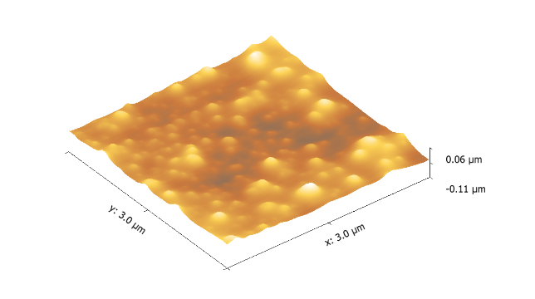
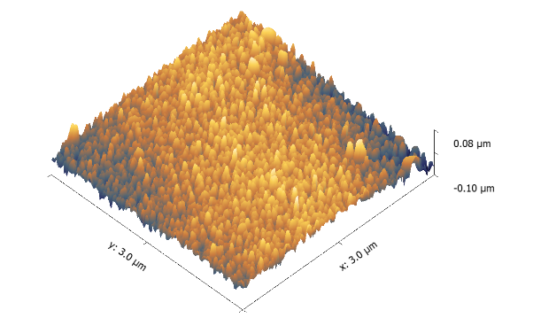
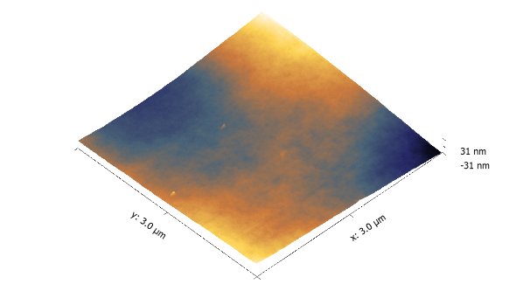
(S_{a}): 10.2 nm
(S_{q}): 12.77nm
b
(S_{a}): 16.5 nm
(S_{q}): 20.8 nm
c
a
(S_{a}): 6.66 nm
(S_{q}): 8.78 nm

Figure 5. The alteration of topography and roughness of untreated (a), air plasma-treated (b) and PSU-PMAA-DADPA films

  - ATR-FTIR
ATR-FTIR spectra of the original and surface modified PSU films shown in Figure 6 confirmed the surface modification process. For the PSU–PMAA film, the peak at 1695 cm⁻¹ was due to the carbonyl adsorption in the –COOH groups. In the spectrum of the PSU–PMAA–DADPA film, the broad adsorption between 3100 and 3500 cm⁻¹ was due to the –NH₂ groups of DADPA and the peak at 1650 cm⁻¹ was attributed to amide bonds formed between the –COOH groups of MAA and the –NH₂ groups in DADPA.

1695
1650
3500
3100
a
b
c
d

Figure 6. ATR-FTIR spectra of (a) untreated PSU film, (b) plasma treated PSU film, (C) PSU-PMAA and (d) PSU-PMAA-DADPA film

- Conclusions
This research aimed to improve the hydrophilic properties of PSU film and maintain the stability of the gained properties over time. This has been successfully obtained by using air plasma and then post-grafted with methacrylic acid (MAA) followed by reaction with amine groups. The resulted material characterised by active sites which can consequently react with functionalised molecules such as CDs and potentially applied in drug delivery system such as analgesic drugs e.g. Ketoprofen, Meloxicam and Ibuprofen. In terms of contact angles and surface energies results, we obtained improvement in hydrophilic properties of PSU film treated by low-pressure air plasma followed by grafting with hydrophilic monomer (MAA) and then amination with DADPA (PSU-PMAA-DADPA film). This study confirmed that grafting yield increased by increasing time of plasma treatment. As result of this plasma-induced graft polymerization and the amination after that follows, the improvement of hydrophilic properties of the surface of PSU film can be permanent, as evidenced by the constancy of modified PSU film over time, even after 40 days. Thus, our research endowed the modified films with various active groups with surface properties that render them desirable candidates for drug delivery.

References
1. Du, R., B. Gao, and Y. Li, Hydrophilic polysulfone film prepared from polyethylene glycol monomethylether via coupling graft. Applied Surface Science, 2013. 274: p. 288-294.
2. Park, J.Y., et al., Polysulfone-graft-poly(ethylene glycol) graft copolymers for surface modification of polysulfone membranes. Biomaterials, 2006. 27(6): p. 856-865.
3. Modarresi, S., et al., Effect of low-frequency oxygen plasma on polysulfone membranes for CO2/CH4 Separation. Journal of Applied Polymer Science, 2012. 124(S1): p. E199-E204.
4. Xiang, T., et al., Facile chemical modification of polysulfone membrane with improved hydrophilicity and blood compatibility. Materials Letters, 2014. 137: p. 192-195.
5. Mangindaan, D., et al., Modulation of biocompatibility on poly(vinylidene fluoride) and polysulfone by oxygen plasma treatment and dopamine coating. Journal of Biomedical Materials Research Part A, 2012. 100A(11): p. 3177-3188.
6. Chittrakarn, T., et al., Plasma induced graft polymerization of hydrophilic monomers on polysulfone gas separation membrane surfaces. Surface and Coatings Technology, 2016. 296: p. 157-163.
7. Sheila Shahidi, J.W.a.M.G., Surface Modification Methods for Improving the Dyeability of Textile Fabrics, in Eco-Friendly Textile Dyeing and Finishing, M. Günay, Editor 2013.
8. Mather, R.R., 13 - Surface modification of textiles by plasma treatments A2 - Wei, Q, in Surface Modification of Textiles2009, Woodhead Publishing. p. 296-317.
9. Wavhal, D.S. and E.R. Fisher, Membrane Surface Modification by Plasma-Induced Polymerization of Acrylamide for Improved Surface Properties and Reduced Protein Fouling. Langmuir, 2003. 19(1): p. 79-85.
10. Carrino, L., W. Polini, and L. Sorrentino, Ageing time of wettability on polypropylene surfaces processed by cold plasma. Journal of Materials Processing Technology, 2004. 153–154: p. 519-525.
11. Slepička, P., et al., Argon plasma irradiation of polypropylene. Nuclear Instruments and Methods in Physics Research Section B: Beam Interactions with Materials and Atoms, 2010. 268(11–12): p. 2111-2114.
12. Kim, H.I. and S.S. Kim, Plasma treatment of polypropylene and polysulfone supports for thin film composite reverse osmosis membrane. Journal of Membrane Science, 2006. 286(1–2): p. 193-201.
13. Gancarz, I., et al., Modification of polysulfone membranes. 2. Plasma grafting and plasma polymerization of acrylic acid. Acta Polymerica, 1999. 50(9): p. 317-326.
14. Prabaharan, M. and S. Gong, Novel thiolated carboxymethyl chitosan-g-β-cyclodextrin as mucoadhesive hydrophobic drug delivery carriers. Carbohydrate Polymers, 2008. 73(1): p. 117-125.
15. Ruiz-Palomero, C., M.L. Soriano, and M. Valcarcel, β-Cyclodextrin decorated nanocellulose: a smart approach towards the selective fluorimetric determination of danofloxacin in milk samples. Analyst, 2015. 140(10): p. 3431-3438.
16. Nierstrasz, V.A., 3 - Textile-based drug release systems A2 - Langenhove, L. Van, in Smart Textiles for Medicine and Healthcare2007, Woodhead Publishing. p. 50-73.
17. Tiwari, G., R. Tiwari, and A.K. Rai, Cyclodextrins in delivery systems: Applications. Journal of Pharmacy and Bioallied Sciences, 2010. 2(2): p. 72-79.
18. Ma, Z., K. Masaya, and S. Ramakrishna, Immobilization of Cibacron blue F3GA on electrospun polysulphone ultra-fine fiber surfaces towards developing an affinity membrane for albumin adsorption. Journal of Membrane Science, 2006. 282(1–2): p. 237-244.
19. Gancarz, I., G. Poźniak, and M. Bryjak, Modification of polysulfone membranes: 3. Effect of nitrogen plasma. European Polymer Journal, 2000. 36(8): p. 1563-1569.

